

**DAYANANDA SAGAR UNIVERSITY**

**A SOFTWARE ENGINEERING PROJECT REPORT**

**ON**

**TITLE : RAILWAY MANAGEMENT SYSTEM**

**BACHELOR OF TECHNOLOGY**

**IN**

**COMPUTER SCIENCE & ENGINEERING**

**TEAM MEMBERS:**

***MUSKAAN GOEL (ENG18CS0176)***

***MUSKAAN SINHA (ENG18CS0178)***

***MEGHANA SHREE M (ENG18CS0165)***

***LYSETTI LAKSHMI POOJITHA (ENG18CS0150)***

**DAYANANDA SAGAR UNIVERSITY**

**School of Engineering, Kudlu Gate, Bangalore-560068**



**CERTIFICATE**

**This is to certify that Mr/Ms. -----------bearing USN--------, has satisfactorily completed their Software Engineering Practice Lab Report as prescribed by the University for the Fifth semester B.Tech. Program in Computer Science & Engineering during the year 2020 at the School of Engineering, Dayananda Sagar University, Bangalore**

**Date:**

**Faculty in Charge**

**Chairman**

**Department of Computer Science & Engineering**

**ACKNOWLEDGEMENT**

The success and final outcome of this software requirement document required a lot of guidance and assistance from many people and we are extremely privileged to have got this all through the completion of the project. All that we have done is only due to such supervision and assistance and we would not forget to thank them.

We respect and thank________, Professor and Chairman, for providing us an opportunity to do the Software Requirement Document and giving us all support and guidance which made me complete the project duly. We are extremely thankful to him for providing such a nice support and guidance, even though he has a busy schedule managing the departmental affairs.

We owe our deep gratitude to our mentor___________, who took keen interest on our Software Requirement Document and guided us all along, till the completion of our project work by providing all the necessary information for developing a good system document.

We are thankful to, and fortunate enough to get constant encouragement, support and guidance from all Teaching staffs of the Computer Science Engineering department, which helped us in successfully completing our report. Also, we would like to extend our sincere esteems to all staff in the laboratory for their timely support.

**Student Names**

1. *MUSKAAN GOEL*
2. *MUSKAAN SINHA*
3. *MEGHANA SHREE M*
4. *LYSETTI LAKSHMI POOJITHA*

**Table of Contents**

|  |  |  |
| --- | --- | --- |
| **S. No.** | **Topic** | **Page No.** |
| **1.** | **Introduction**  **1.1 Problem Statement** | **5-6** |
| **2.** | **Vision Document** | **7** |
| **3.** | **Glossary** | **8** |
| **4.** | **Supplementary Specification Docs.** | **9-12** |
| **5.** | **Use Case**  **5.1 Actors**  **5.2 Use Case**  **5.3 Diagram**  **5.4 Description**  **5.5 Activity Diagram** | **13-15** |
| **6.** | **Design Model**  **6.1 Class Diagram**  **6.2 Sequence Diagram** | **16-18** |
| **7.** | **Component Diagram(Deployment Model)** | **19-20** |
| **8.** | **Conclusion** | **21** |
| **9.** | **References** | **21** |

**1.Introduction**

Database is an organized collection of data. The data is typically organized to model aspects of reality in a way that supports processes requiring information. A DBMS makes it possible for end users to create, read, update and delete data in a database. The DBMS essentially serves as

An interface between the database and end users or application programs, ensuring that data is consistently organized and remains easily accessible. The DBMS manages three important things: the data, the database engine that allows data to be accessed, locked and modified and the database schema, which defines the database’s logical structure. These three foundational elements help provide concurrency, security, data integrity and uniform administration procedures. The DBMS can offer both logical and physical data independence. That means it can protect users and applications from needing to know where data is stored or having to be concerned about changes to the physical structure of data.

The main purpose of maintaining database for Railway Reservation System is to reduce the manual errors involved in the booking and cancellation of tickets and make it convenient for the customers and providers to maintain the data about their customers and also about the seats available at them.Due to automation many loopholes that exist in the manual maintenance of the records can be removed. The speed of obtaining and processing the data will be fast. For future expansion the proposed system can be web enabled so that clients can make various enquiries about trains between stations. Due to this, sometimes a lot of problems occur and they are facing many disputes with customers. To solve the above problem, we design a database which includes customer details, availability of seats in trains, no of trains and their details.

**1.1 Problem Statement**

This project is about creating the database about Railway Reservation System. The railway reservation system facilitates the passengers to enquire about the PNR status and book a ticket.

The aim of case study is to design and develop a database maintaining the records of different trains, train status, and passengers. The record of train includes its number, name, source, destination, and days on which it is available, whereas record of train status includes dates for which tickets can be booked, total number of seats available, and number of seats already booked.

Passengers can book their tickets for the train in which seats are available. For this, passenger has to provide the desired train number and the date for which ticket is to be booked. Before booking a ticket for a passenger, the validity of train number and booking date is checked. Once the train number and booking date are validated, it is checked whether the seat is available. If yes, the ticket is booked with confirm status and corresponding ticket ID is generated which is stored along with other details of the passenger. The ticket once booked can be cancelled at any time. For this, the passenger has to provide the ticket ID (the unique key). The ticket ID is searched and the corresponding record is deleted. With this, the first ticket with waiting status also gets confirmed.

List of trains has to be maintained. Detailed Passenger information is to be maintained In the booking procedure, the train number, train date, and category are read from the passenger. On the basis of the values provided by the passenger, a corresponding record is retrieved from the Train_Status. If the desired category is AC, then the total number of AC seats and number of booked AC seats are compared in order to find whether tickets can be booked or not. Similarly, it can be checked for the general category.

**2.Vision document:**

Railway management system is an attempt to simulate the basic concepts of an online reservation system . the system enables to perform the following function:

* Search for train
* Providing facilities for booking a railway tickets
* Enquire facilities
* Facilities for cancellation of tickets
* Facilities for refunds.
* Managing users
* Managing the database for users and transaction
* Improved and optimized service

**3. Glossary**

Glossary summarises the technical terms used in the project. It's basically a dictionary of words used or referred to in the project.

Here are some of the words we have used in “Railway Management System”.

* NTES: National Train Enquiry System
* PRS: Passenger Reservation System
* UCD: Use Case Diagram
* CD: Class Diagram
* SD: Sequence Diagram
* SCD:State Chart Diagram
* PNR:Passenger Name Record
* SRS: Software Requirement Specification

**4 SUPPLEMENTARY SPECIFICATION DOCS:**

**4.1 Function Requirements**

4.1.1 performance requirements:

* **User Satisfaction**: - The system is such that it stands up to the user expectations.
* **Response Time**: -The response of all the operations is good. This has been made possible by careful programming.
* **Error Handling**: - Response to user errors and undesired situations has been taken care of to ensure that the system operates without halting.
* **Safety and Robustness**: - The system is able to avoid or tackle disastrous action. In other words, it should be foul proof. The system safeguards against undesired events,without human intervention.
* **Portable**: - The software should not be architecture specific. It should be easily transferable to other platforms if needed.
* **User friendliness:** - The system is easy to learn and understand. A native user can also use the system effectively, without any difficulties.

**4.1.2 Design constrian:**

There are a number of factors in the client’s environment that may restrict the choices of a designer. Such factors include standards that must be followed, resource limits, operating environment, reliability and security requirements and policies that may have an impact on the design of the system. An SRS (Software Requirements Analysis and Specification)

should identify and specify all such constraints.

* **Standard Compliance: -** This specifies the requirements for the standards the system must follow. The standards may include the report format and accounting properties
* **Hardware Limitations :-** The software may have to operate on some existing or predetermined hardware, thus imposing restrictions on the design. Hardware limitations can include the types of machines to be used, operating system available on the system,languages supported and limits on primary and secondary storage.
* **Reliability and Fault Tolerance: -** Fault tolerance requirements can place a major constraint on how the system is to be designed. Fault tolerance requirements often make the system more complex and expensive. Requirements about system behavior in the face of certain kinds of faults are specified. Recovery requirements are often an integral part here, detailing what the system should do some failure occurs to ensure certain properties.Reliability requirements are very important for critical applications.
* **Security: -** Security requirements are particularly significant in defence systems and database systems. They place restrictions on the use of certain commands, control access to data, provide different kinds of access requirements for different people, require the use of passwords and cryptography techniques and maintain a log of activities in the system.

**4.1.3 Hardware requirements:**

For the hardware requirements the SRS specifies the logical characteristics of each interface

b/w the software product and the hardware components. It specifies the hardware

requirements like memory restrictions, cache size, the processor, RAM size etc... those are

required for the software to run.

* **Minimum Hardware Requirements**

Processor Pentium III

Hard disk drive 40 GB

RAM 128 MB

Cache 512 kb

* **Preferred Hardware Requirements**

Processor Pentium IV

Hard disk drive 80 GB

RAM 256 MB

Cache 512 kb

**4.1.4 Software requirements:**

Any window based operating system with DOS support are primary requirements for software development. Windows XP, FrontPage and dumps are required. The systems must be connected via LAN and connection to the internet is mandatory.

**4.1.5 Other requirements:**

Software should satisfy following requirements as well:-

* SECURITY
* PORTABILITY
* CORRECTNESS
* EFFICIENCY
* FLEXIBILITY
* TESTABILITY
* REUSABILITY

**4.2 Non-Functional Requirements:**

**4.2.1 Security:**

The system use SSL (secured socket layer) in all transactions that include any confidential customer information. The system must automatically log out all customers after a period of inactivity. The system should not leave any cookies on the customer’s computer containing the user’s password. The system’s back-end servers shall only be accessible to authenticated

Management.

**4.2.2 Reliability:**

The reliability of the overall project depends on the reliability of the separate components.The main pillar of reliability of the system is the backup of the database which is continuously maintained and updated to reflect the most recent changes. Also the system will be functioning inside a container. Thus the overall stability of the system depends on the stability of the container and its underlying operating system.

**4.2.3 Availability:**

The system should be available at all times, meaning the user can access it using a web browser, only restricted by the down time of the server on which the system runs. A customer friendly system which is in access of people around the world should work 24 hours. In case of a of a hardware failure or database corruption, a replacement page will be shown. Also in case of a hardware failure or database corruption, backups of the database should be retrieved from the server and saved by the Organizer. Then the service will be

restarted. It means 24 x 7 availability.

**4.2.4 Maintainability:**

A commercial database is used for maintaining the database and the application server takes care of the site. In case of a failure, a re-initialization of the project will be done. Also the software design is being done with modularity in mind so that maintainability can be done Efficiently.

**4.2.5 Supportability:**

The code and supporting modules of the system will be well documented and easy to understand. Online User Documentation and Help System Requirements.

1. **USE CASE:**

Use case diagram is a graphic depiction of the interactions among the elements of the Railway Management System. It represents a methodology used in system analysis to identify,clarify and organise system requirements of Railway Management System.

**5.1 - Actors:**

The main actors of Railway Management System in the above use case diagram are :

* Super Admin
* System Users
* Station Masters
* Passengers They perform different types of use cases such as
* Managing Trains
* Managing Time-Table
* Managing Fare
* Managing Stations
* Managing Seats Availability ; etc.

**5.2 - Use-Case:**

Use cases were developed originally to support requirements elicitation and now incorporated into the UML.Each use case represents a discrete task that involves external interaction with a system.Actors in a use case may be people or other systems.Represented diagrammatically to provide an overview of the use case and in a more detailed textual form.

**5.3 - Diagram:**

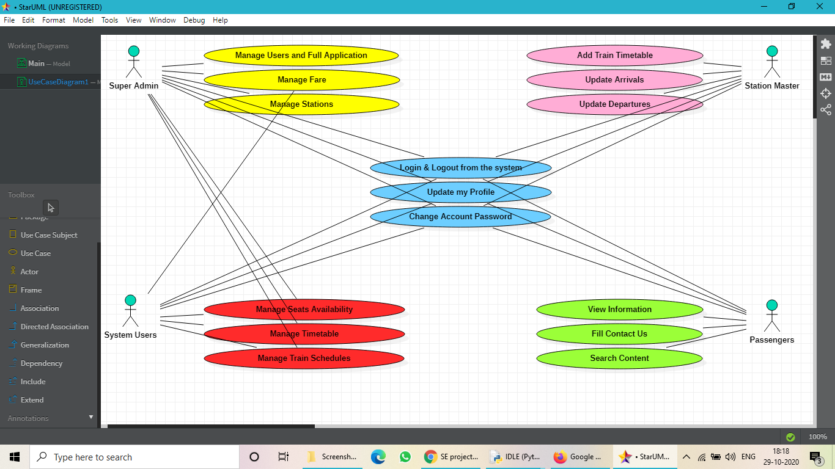

**5.4 - Description:**

* **System User Entity** : Use cases of System User are Manage Seats Availability, Manage Timetable, Manage Train Schedule.
* **Super Admin Entity** : Use cases of Super Admin are Manage Users and Full Applications, Manage Fare, Manage Stations.
* **Station Master Entity** : Use cases of Station Master are Add Train Timetable,Update Arrivals,Update Departures.
* **Passengers Entity** : Use cases of Passengers are View Information, Fill contact Us, Search Content.

**5.5 - Activity Diagram:**

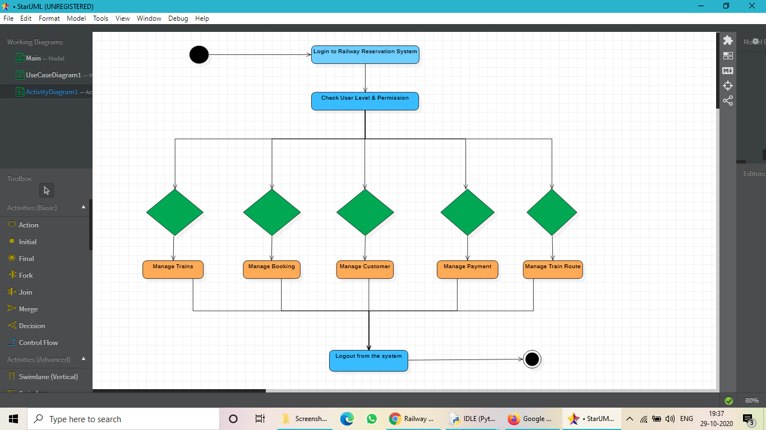

This is the Activity UML Diagram of Railway Reservation System which flows between the activity of Ticket,Customer,Payment,Booking,Train Schedule.

The main activity involved in the Railway Management System are :

* Ticket Activity
* Customer Activity
* Payment Activity
* Booking Activity
* Train Schedule Activity

User logs in to the system and checks user level and permissions. Then Trains, Booking, Customers, Payment and Train Route are managed. The User then logs out from the system.

1. **Design Model**

The design model is an object model describing the realization of use cases, and serves as an abstraction of the implementation model and its source code. The design model is used as essential input to activities in implementation and test.

**6.1 Class Diagram**

Railway management system class diagram describes the structure of railway management classes, their attributes,operations and the relation among objects. The main classes of railway management system are stations, booking, customers, trains, timetable and employee.

**Classes of Railway Management System:**

* **Stations class:** manages all the operations of stations
* **Booking class:** manages all the operations of booking
* **Customers class:** manages all the operations of customers
* **Trains class:** manages all the operations of trains
* **Timetable class:** manages all the operations of timetable
* **Employee class:** manages all the operations of employee

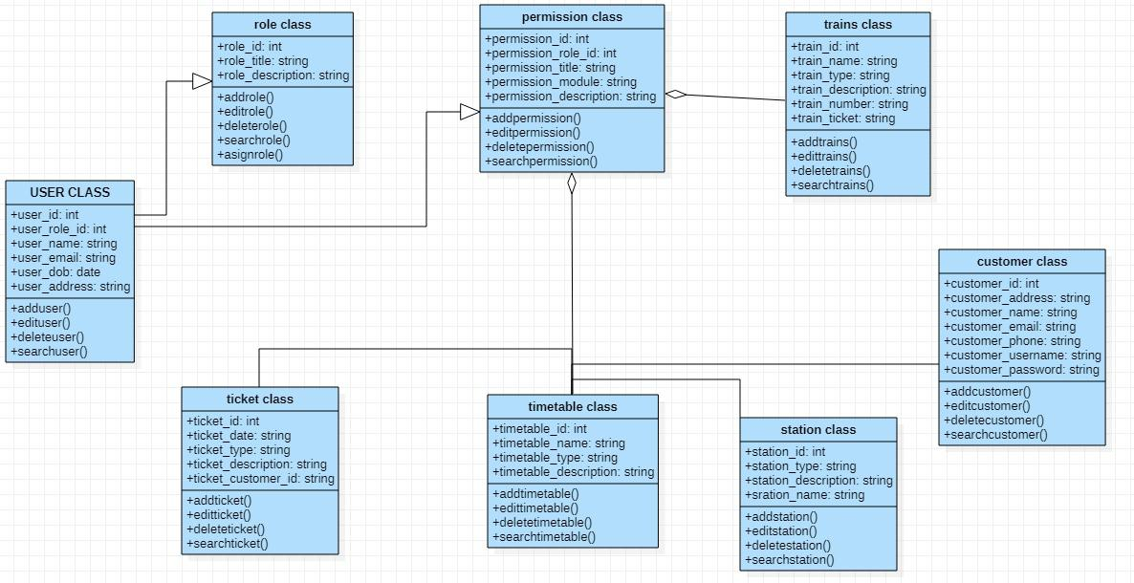

**6.2 Sequence Diagram**

This is the login sequence diagram for the Railway management system where admin will be able to login in their account using their credentials. After login user can manage all the operations on customer booking,train route, ticket and payment .All the pages such as train Routes,ticket,payment are secure and user can access these pages after login.The diagram below helps demonstrate how the login page works in a railway management system the various objects in the ticket, customer ,booking ,train route and payment page- interact over the course of the sequence and user will not be able to access this page without verifying their identity.

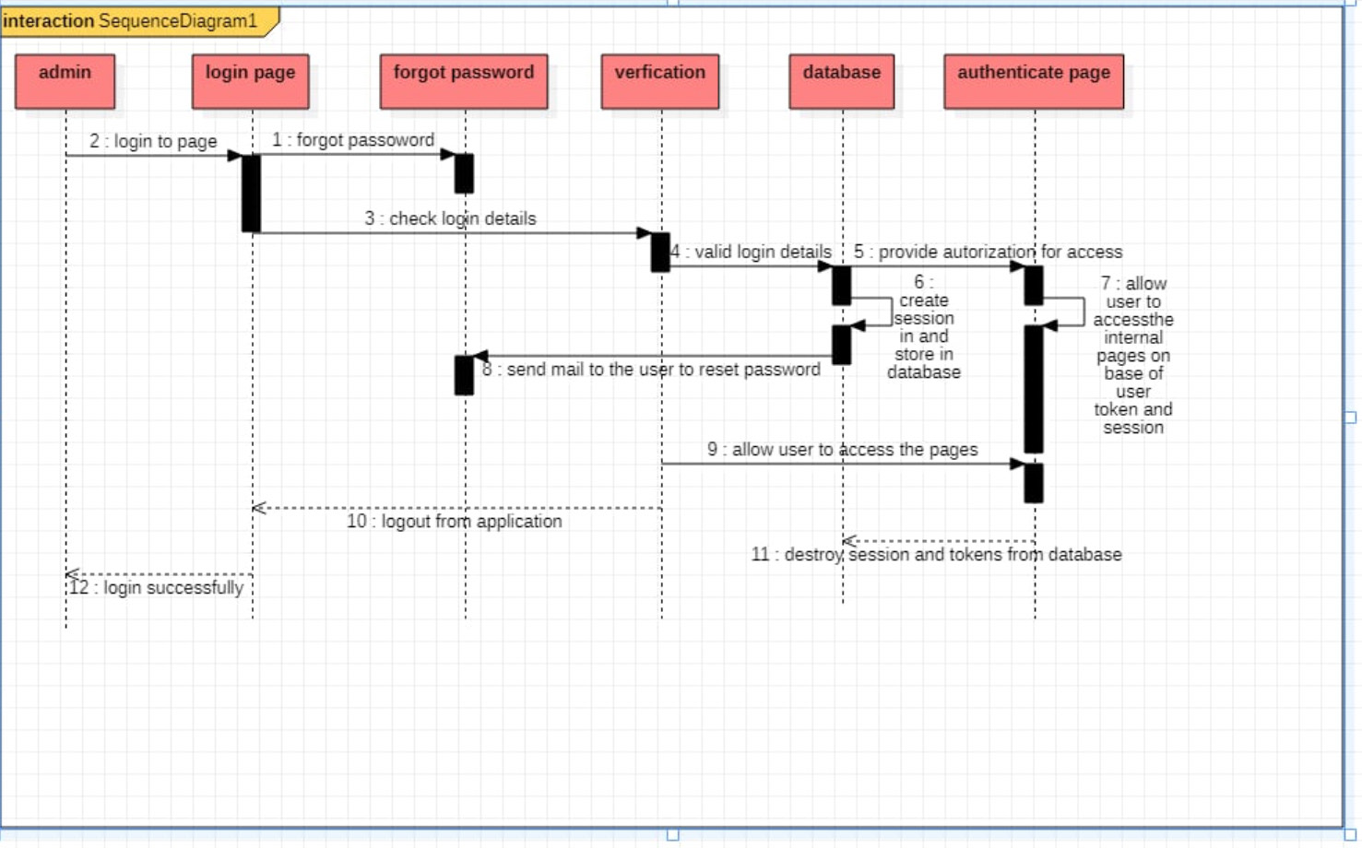

**7.Deployment Diagram**

The concept of deployment in data science refers to the application of a model for prediction using new data. Building a model is generally not the end of the project. Even if the purpose of the model is to increase knowledge of the data, the knowledge gained will need to be organized and presented in a way that the customer can use it.

Here the deployment diagram of the railway management system can be understood by this diagram.We have taken three passengers as an example here, passenger 1, passenger 2 and passenger 3. The passengers use the railway management web server, while it leads to the application server and database server. Also the railway management web server helps to issue the ticket of the customer to the desired destination with the booking and trains available.

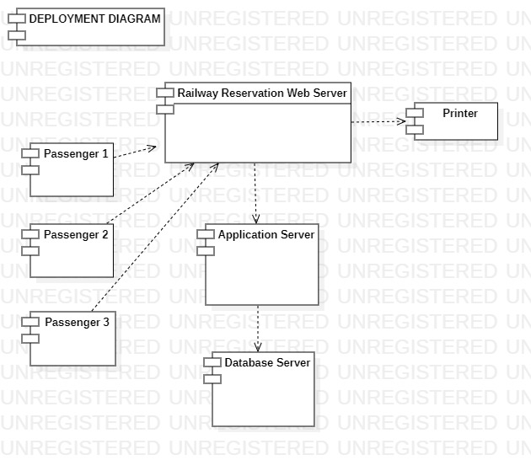

**8. Conclusion**

In this project, we design and achieve a railway online ticketing system. The system is structured into the data access layer, business. We implement customer registration, customer cancellation, ticket inquiries, online booking, online ticket refund in the system . Business process design and database design is the focus of this system which are clearly and effectively designed by the business process diagrams and database ER diagrams. The efficiency of booking is improved, manual booking errors is reduced, the management of railway passenger transport and customer booking is facilitated.

**9.References**

<https://fdocuments.in/document/srs-for-railway-reservation-system.html>

https://www.freeprojectz.com/uml-diagram/railway-management-system-uml-diagram